Evolution

Evolution is the change in the characteristics of a population over time; it may also result in the formation of new species. The theory of evolution is that organisms have developed from pre-existing forms over many millions of years and that different organisms today have common ancestors. Some organisms have evolved along different lines because of different environmental pressures.

Evolution by Natural Selection
This theory was put forward by Wallace and Darwin.

- There is great genetic variation within each population.
- Population size remains constant even though organisms produce many offspring.
- Therefore severe competition for limited resources takes place —‘survival of the fittest’.

The individuals with the best-adapted genetically determined characteristics survive.
The better-adapted individuals produce more offspring than the less well adapted.
The next generation is genetically closer to the better adapted individuals of the previous generation. With each generation the population becomes better adapted to its environment.
Evidence for Evolution

Comparative Anatomy is the study of the structural similarities and differences of living organisms.Many structures, which appear quite different, have been shown to have the same basic design. Structures that are different yet similar are said to be homologous. The pentadactyl limb of four-limbed vertebrates is an example.

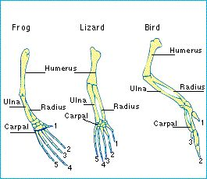
Modifications of the basic design include:

- bat wing for flying
- whale fin for swimming
- horse leg for running
- human arm for grasping

The examples above indicate that they descended from a common ancestor.

Evolution of the Horse

A fossil is the remains or imprint in rock of an organism that lived millions of years ago. Lower or older layers of rock have fewer and less complex fossils than the more recently formed rock. Many of the fossils found in older rock layers are of extinct organisms and few fossils of existing organisms are found. This fact suggests that there has been a progression over a long period of time from a simple to a more complex life form.

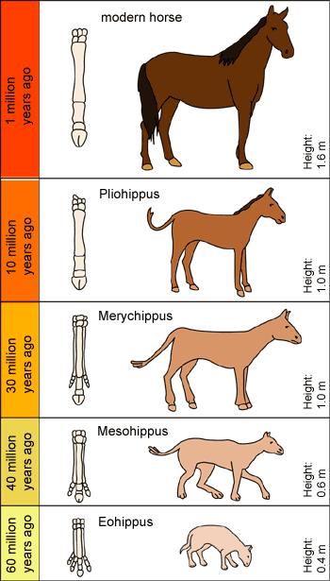
As more and more horse fossils have been found, some ideas about horse evolution have developed

- The modern horse appeared 1 million years ago

- Pliohippus was between 1m 1.3 m high and appeared 10 million years ago.

- Meryhippus appeared 30 million years ago and was slightly larger again at 1 m high,

- 45 million years ago fossils show that Miohippus appeared. It was larger at about 60 cm.

- The earliest horse Eohippus lived about 60 million years ago and had a height of about 40 cm.

The fossil record also show a change in the size of the horses teeth, from low crowned to high and in the number of toes touching the ground from 4 in Eohippus to 1 in the modern horse. These changes suggest that the horses had to continually adapt to environmental changes from leafy jungle like conditions to open grassland.

